Miguel Acosta Del Vecchio
April 17, 2021
ECE 3712 – Introduction to Electromagnetic Fields and Waves
Project 2
Introduction:
Magnetostatics is the study of magnetic fields such as ones generated by a steady electric current or a permanent magnet. There are many applications of magnetostatics such as magnetic storage devices in computer memory, scanning machines, and tight seal on the doors to refrigerators and freezers. Currently there are two methods that can be used to calculate the numerical solution of magnetostatic problems. The vectorial magnetic field approach will be used to analyze the vector magnetic potential instead of the scalar magnetic field approach.

Problem Statement:
The purpose of this project is to find the vector magnetic potential and magnetic field from a region with nonuniform current density and an iron block. The size of the grid, as well as the conductors’ and iron’s position can be seen in Figure 1 below. The conductor in the first quadrant has a current of 10 amps, and the conductor in the third quadrant has a current of -10 amps. The iron block has a µr equal to 5000. Afterwards, it is imperative to find the analytical solution of the magnetic flux density without the iron square to verify Ampere’s Law for a loop with one conductor as well as two. At last, it is important to consider the changes of the magnetic field produced by the conductors when AC is applied at 60 Hz instead of a constant current of 10 amps and -10 amps in the corresponding conductor.
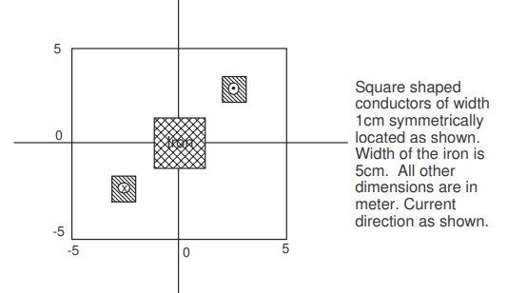
Figure 1: This image shows the size of the grid, the position of the conductors inside of the grid as well as the position of the iron block with all of the appropriate widths and lengths.

Basic Concepts:
To solve the given problem, it is first necessary to discover how to measure the magnetic flux density at each node in the grid. First, it is important to consider the current density equation at any grid point ( i , j ). The following shows the current density equation:
$$J_{i,j}=\frac{I_{i,j}}{Area}$$ | Current Density Equation (1)
Based on the current density equation it is possible to see that the current density at each node located in ( i , j ) is equal to the current at the grid point divided by the whole area of the grid. Then, it is necessary to find the equation for the permeability at each node in the grid. This can be done by using the Equation 2 below.
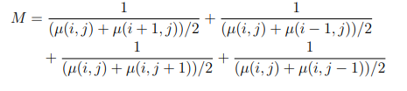 | Permeability Equation (2)

Now that the permeability and current density of the grid is known, it is possible to calculate the magnetic potential at each node in the grid using Equation 3 below.
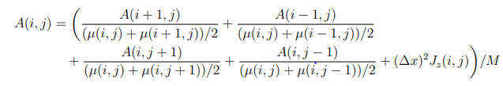 | Magnetic Potential Equation (2)
At last, due to the fact that the magnetic potential is known it is possible to calculate the magnetic flux intensity by using Equation 4 below.
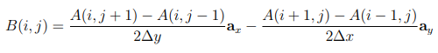 | Magnetic Flux Intensity Equation (3)
It is important to note that the solution can be much more accurate by discretizing the domain to a finer grid in which Δx and Δy are small. Due to this, many more equations must be solved simultaneously and demand more computer time and memory.
The algorithm created to solve for the magnetic flux intensity at each grid point begins by first displacing the grid plane where the conductors are located into the first quadrant and scaling the plane to go from 0 to 40 units from side to side. Then, when the conductors have been placed in the corresponding location and size in the first quadrant, four matrices will be created to model the plane where the conductors and iron are located. The first matrix will be used to model the current density at each node using Equation 1. The second matrix will be used to model the permeability of the grid where each node will have a permeability of $µ_{0}$ except where the iron block is located which will have a permeability of $µ_{0}*5000$, where 5000 is the permeability of iron. The third matrix will be used to model the magnetic potential at each node by using Equation 2 above and the starting elements are all zero. The last matrix will be used to model the magnetic flux intensity at each node by using Equation 3 above and all of the starting elements are zero. It is important to keep in mind that the conductor in quadrant one will have a current equal to 10 amps because the current direction is in the positive z-direction, and the conductor in quadrant 3 will have a current of -10 because the current direction is in the negative z-direction. It is important to keep in mind, that the conductors were squares of width 0.1 but due to the scaling, they are now 4 units wide. Now that the matrices that model each node in the grid are ready, the next step is to build an algorithm that will calculate the magnetic flux intensity at each node in the grid many times to make the numbers converge close to the real value. This algorithm will specifically update the permeability and magnetic potential at each node in the grid 2000 times to make sure the number converges close to the real value. The last step needed to fully build an algorithm that will be able to iterate the calculation 2000 times is to model the equations for the magnetic potential and permeability of the plane. This is done by doing 2 nested for loops. The inner for loop will take care of changing the position of the node in the y direction, and the outer for loop will take care of changing the position of the node in the x direction. Inside of the 2 nested for loops, the magnetic potential and the permeability of the plane will be calculated. Overall, the algorithm will calculate the magnetic potential and permeability of the grid node by node inside of the corresponding matrix starting at element (2,2) going down to the column and every time it finishes a column it will move to the next column to the right until the whole matrix is done.
After the values inside of the magnetic potential matrix converged, it is now possible to find the magnetic flux intensity by using Equation 3. To model the equation in MATLAB, the same process will be done in which 2 nested for loops will be done. The inner for loop will take care of changing the position of the node in the y direction, while the outer for loop will take care of changing the position of the node in the x direction.
Now that the magnetic potential and magnetic flux intensity are known for each node in the grid, it is now possible to draw the equipotential lines in the domain, as well as the contour plot of constant field intensity. Using MATLAB, the function called “contour and “quiver” were used to draw the equipotential lines and contour plot along the corresponding matrix of magnetic potential or magnetic flux intensity as input.
To verify that Ampere’s Law holds in this problem, the analytical solution was calculated in MATLAB. The assumptions made in the analytical solution are that the iron piece is neglected, and the conductor is an infinite wire of infinitesimal width. After making these assumptions, it is now possible to calculate the magnetic field at each node in the grid by using Equation 4 below.
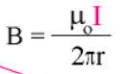 | Magnetic Field due to Infinite Wire (4)
From Equation 4, it is important to note that r is the distance from the location in the grid to the location of the conductor. It is now necessary to make an Ampere’s loop around conductor. In MATLAB, the loop was of size 6 by 6 and enclosed the top conductor in the grid. Another loop was done for both conductors which was the same size as the grid itself. Then, to calculate the enclosed current, Ampere’s Law equation shown below was used.
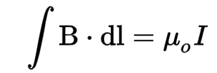 | Ampere’s Law Equation (5)
To do this calculation in MATLAB, the integral was simulated by using a summation instead which can then be modeled by a for loop. Inside of the for loop it is possible to sum the magnetic field at each node by using Equation 4 above.
The analytical solution for the magnetic field for every point in the grid was calculated by using Equation 4 above. At every point in the grid, the corresponding distance was calculated from each conductor, and then the result was inputted into Equation 4 to find the corresponding magnetic field from each conductor. Afterwards, the magnetic field from each conductor was added to obtain the final value for the analytical magnetic field at each node in the grid.
At last, supposing the conductor is carrying an alternating current at 60Hz, how the magnetic field changes is equal to derivative with respect to time of the magnetic field. The known equation for the magnetic field as a function of time is shown in Equation 5 below.
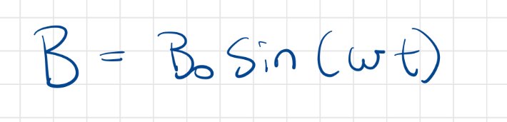 | Magnetic Field as a Function of Time Equation (6)
Based on Equation 6 above, it is now possible to find how the magnetic field changes with respect to time by taking the derivative of both sides of the equation and replacing omega with 2*π*60.

Results:
After writing the code in MATLAB and explaining how the code worked in the Basic Concepts section of this report, the following results were obtained.
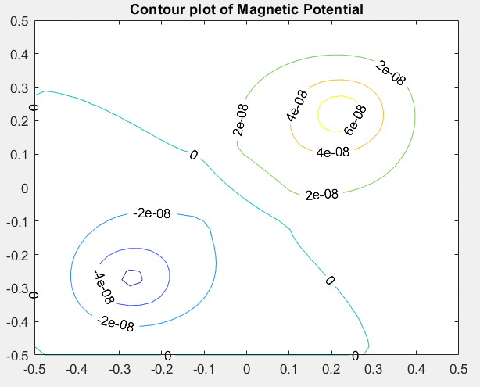
Figure 2: Equipotential lines in the Domain. This graph was created by plotting the Magnetic Potential in the given domain.
According to Figure 2 above, it is possible to see the equipotential lines created from the 2 conductors that were given. By using reason, it is possible to see that the equipotential lines make sense because at nodes close to the top conductor, the magnetic potential is higher than at nodes farther away from the conductor. At nodes close to the bottom conductor, the magnetic potential is also stronger closer to the wire and weaker the farther it is from the conducting wire. It is also important to note that because the 2 wires have the same amount of current passing through them in opposite directions, there should be no magnetic potential at the symmetrical line of the 2 conductors, which is exactly what is shown in Figure 2 above.
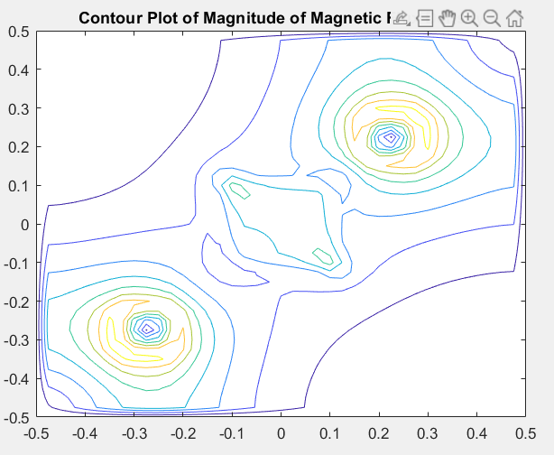
Figure 3: Contour Plot of Magnitude of Magnetic Flux Density. This graph was created by plotting the magnitude of the vectors of magnetic flux density at each node.
Next is the contour plot of Magnitude of Magnetic Flux Density that was calculated based on the magnetic potential at each node using Equation 3 and then performing the Pythagorean Theorem to calculate the magnitude of magnetic flux density at each node. It is possible to see that the results shown in Figure 3 make sense because it is expected that the there will be strong magnetic flux density both near each conductor and in the middle of the 2 conductors because the conductors are conducting current in opposite direction and therefore producing a net magnetic flux density near the symmetrical lines that divides the 2 conductors.
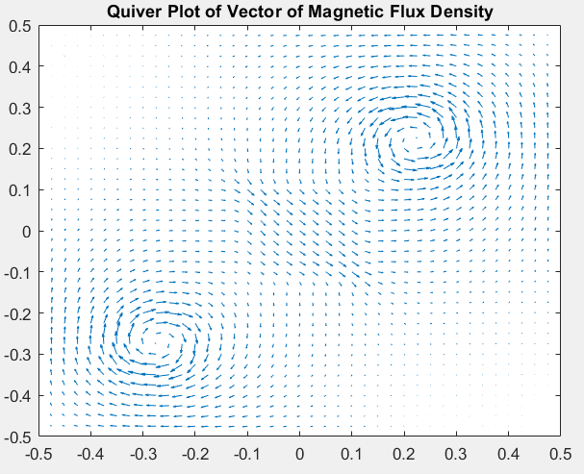
Figure 4: Quiver Plot of Vector of Magnetic Flux Density. This graph was created by plotting the X and Y vector of magnetic flux density at each node.
The quiver plot of vector of magnetic flux density shown above in Figure 4 was calculated based on the magnetic potential at each node using Equation 3. It is possible to see that the image makes sense because using the right-hand rules for the bottom conductor which has a current direction in the negative z-axis, the magnetic flux density direction with respect to the conductor should be clockwise. On the other hand, using the right-hand rule on the top conductor which has a current direction in the positive z-axis, the magnetic flux density direction with respect to the conductor should be counterclockwise. Also, the closer the nodes are to each conductor, the stronger the magnetic flux density. It is also important to note that there is a strong magnetic flux density in the middle between the 2 conductors due to a net magnetic flux density in the bottom right direction which can be better seen in Figure 4 above.
Now, the left side of Equation 5 above for the Ampere loop that holds the 2 conductors in the grid was found to be 0 amps, which makes sense because the enclosed current or the right side of Equation 5 should equal to zero because the currents from both conductors are equal and in opposite directions. In other words, both sides of the equation equal to zero which means that Ampere’s Law holds in this scenario.
On the other hand, the left side of Equation 5 above for the Ampere loop that holds only the top conductor in the grid was found to be 13 amps, which makes sense because the enclosed current or the right side of Equation 5 should equal to 10 because the current of the conductor inside of the ampere loop is 10. It is possible to see that the left side of the equation is not exactly what the right side should be, but the numbers are close enough to assume that Ampere’s Law holds in this scenario as well.
After calculating the magnetic field at each point in the grid using Equation 4, the following graph was obtained.
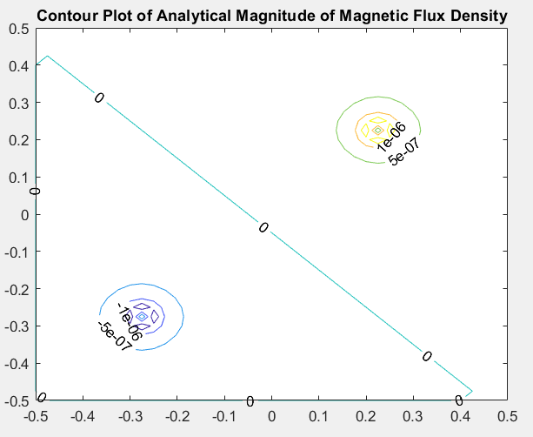
Figure 5: This image shows the Contour plot of the analytical magnitude of magnetic flux density.
It is possible to see from Figure 5 above, that analytical solution of the magnetic field at each point in the grid is very similar to the graph with the actual conductors and iron block shown in Figure 2. Both figures show a magnetic field line of zero at the line that divides both the conductors symmetrically. The analytical solution demonstrates that the real solution should be similar to the theoretical one but should vary due to actual sizes of the conductors as well as the iron block in the middle.
At last, if the conductor were to carry an AC at 60Hz, the magnetic field would oscillate every 60Hz. This can be better shown in Figure 5 below.
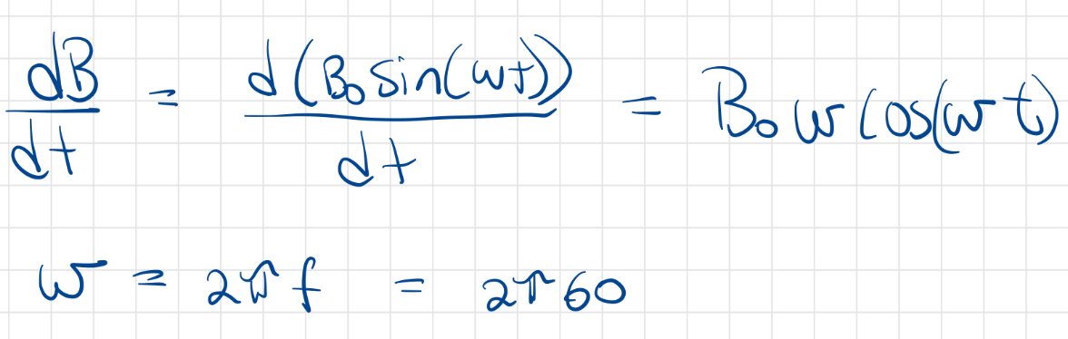
Figure 6: This image shows the equation of the magnetic field changing with respect to time at a frequency of 60Hz.

Conclusions:
This project provided useful and logical illustrations and calculation results about magnetic fields, magnetic flux density and Ampere’s Law. Having the illustration of the contour plot of the magnetic potential and the magnetic flux density made it easier to conceptualize the relationship both physical phenomena. It was also helpful to see how the analytical solution to the problem compared to the real-life problem with actual conductors and iron block. This project was successful because it provided reasonable values and graphs for both the magnetic potential and magnetic flux density, as well as correct analytical solutions that agreed with Ampere’s Law. This project made it easier to understand the concepts by applying them to a real-life problem.

